EVENT MANAGEMENT SYSTEM
A PROJECT REPORT

Submitted By

LAKSHMY P K - ATP24CS064
MRIDULA K - ATP24CS071
NAVANEETH S - ATP24CS079
SHIMA HARIDASAN - ATP24CS103

To
the APJ Abdul Kalam Technological University
in partial fullfilment of the requirements for the award of the degree
of
Bachelor of Technology
In

Computer Science and Engineering

DEPARTMENT OF COMPUTER SCIENCE AND ENGINEERING
Ahalia School of Engineering & Technology Ahalia Campus, Palakkad, Kerala-678557

NOVEMBER 2025



DEPARTMENT OF COMPUTER SCIENCE AND ENGINEERING

CERTIFICATE

This is to certify that the microproject work report entitled ‘Event Management System’ submitted by LAKSHMY P K (ATP24CS064), MRIDULA K (ATP24CS071), NAVANEETH S (ATP24CS079), and SHIMA HARIDASAN (ATP24CS103), of Third Semester, B.Tech in Computer Science & Engineering has been successfully carried out under our supervision and guidance in partial fulfillment of the requirements of the microproject for the subject PBCST304 – Object Oriented Programming, prescribed by APJ Abdul Kalam Technological University, Kerala. It is further certified that this work is a bonafide record of the microproject carried out by the above students during the academic year 2025–2026.

Project Guide
Ms. Happy A
Assistant Professor
Dept. of CSE
.

Professor and Head
Dr. S Gunasekaran
Dept. of CSE.



DEPARTMENT OF COMPUTER SCIENCE AND ENGINEERING

DECLARATION

We hereby declare that the microproject report EVENT MANAGEMENT SYSTEM submitted for the partial fulfilment of the requirements of the Third Semester Microproject for the subject PBCST304 – Object Oriented Programming, prescribed by APJ Abdul Kalam Technological University, Kerala is a bonafide work done by us under the guidance of Asst. Prof. Ms. HAPPY A .The submission represents our ideas in our own words and where ideas or words of others have not been included. We have adequately and accurately cited and referred the original sources.

Place : PALAKKAD Signature of Student

Date :

COUNTERSIGNED

Ms. Happy A

Assistant Professor

Department of CSE

ACKNOWLEDGEMENT

First and foremost, we would like to thank the GOD ALMIGHTY for his infinite grace and help, without which this project would not have reached its completion. We wish to express our sincere gratitude to Dr. P R Suresh , PhD., Principal, Ahalia School of Engineering and Technology for his timely support throughout the course of this project. We extend our sincere thanks to Dr. Krishna Kumar Kishor Ph.D., Vice Principal, for extending all facilities. We express our sincere and heartfelt gratitude to Dr. S. Gunasekaran, Ph.D., Professor and Head of the Department, Department of Computer Science and Engineering for his help and excellent encouragements through the project. We express our deepest, heartiest and sincere thanks to our Project Guide Ms. Happy A, Assistant Professor, for her exhilarating supervision, timely suggestions and encouragement during all phases of this work. We take this opportunity to thank , Mr.Nandu S Nair , our mentor who had been always there with us. Also, we would like to thank all the Teaching faculty members and Supporting Staff of our department. We would like to convey our gratitude to our Parents whose prayers and blessings were always with us. Last but not least we would like to thank our Friends and others who directly or indirectly helped us in successful completion of this work.

INSTITUTION VISION

Grow as a center of learning and research, transforming students to professionals with knowledge, skill, competence, commitment, confidence through decisive learning and contribute to the sustainable development of the society.

INSTITUTION MISSION

- . To instil technical expertise in order to address current and emerging challenges in the quest for creating sustainable and high-quality livelihoods.
- To foster a culture of research, innovation, and entrepreneurship through determined learning.
- To promote an environment that supports the welfare of society through ethical and professional conduct.

DEPARTMENT VISION
To develop computer science engineers with knowledge, computing skills and empowering them to excel in their profession through performance based learning contributing to sustainability, well-being of the society and profssional ethics.

DEPARTMENT MISSION

To implement effective outcome-based education that fosters the development of competent and skilled graduates, empowering them to promote and adopt sustainable practices.To provide students with opportunities to engage in advancements in computer science and engineering through interdisciplinary research, collaborative projects that encourage innovation and entrepreneurship.

LIST OF CONTENTS
S NO: | TOPIC: | PAGE NO:
 | List of figures | 10
 | List of Tables | 11
 | CHAPTER 1 - Introduction | 12
1.1 | Background | 13
1.2 | Relevance | 13
2 | Aim and Objective | 13
2.1 | Objectives | 14
3 | Requirement Specification | 15
3.1 | System Overview | 15
3.2 | Existing System | 16
3.3 | Proposed System | 16
3.4 | Purpose of the System | 17
3.5 | Functional Requirements | 17
3.6 | Non- Functional Requirements | 18
 | CHAPTER 2 - DATABASE DESIGN | 19
2.1 | Introduction to Database Design | 19
2.2 | Database Design Objectives | 19

S NO | TOPIC | PAGE NO
2.3 | Identification of Entities | 21
2.4 | Entity Relationships Explained | 25
2.5 | Advantages of this ER Design | 27
2.6 | Sample Data | 29
2.7 | SQL Queries | 31
 | CHAPTER 3- SYSTEM IMPLEMENTATION | 34
3.1 | Overview | 34
3.2 | Technologies Used | 34
 | CHAPTER 4 - WORKFLOW | 38
 | CHAPTER 5 - SOFTWARE TESTING | 43
5.1 | Testing Strategy and Methodology | 43
5.2 | Test Case and Test Analysis | 43
5.3 | Overall Findings and Quality Assessment | 44
 | CHAPTER 6 - CONCLUSION AND FUTURE ENHANCEMENT | 46
6.1 | Conclusion | 46
6.2 | Future Enhancement | 46
6.3 | Source code | 47
 | References | 53

ABSTRACT

The Event Management System is a Java-based application developed to simplify the process of creating, managing, and monitoring events. It provides role-based access for customers and administrators, ensuring secure and efficient operations. Customers can register, log in, and create events by specifying details such as title, description, type, date, and status. They can also manage attendee lists and submit special requests linked to their events. Administrators are responsible for reviewing all submitted events, verifying details, and approving or rejecting pending requests, thus maintaining organized oversight.
The system is implemented with Java Swing for its graphical user interface, offering an intuitive and interactive experience. Data management is handled through a MySQL database integrated with JDBC, which securely stores user information, event details, attendee records, and special requests. This integration ensures data persistence, accuracy, and easy retrieval whenever required.Developed using object-oriented programming (OOP) principles, the system maintains modularity and scalability. Separate classes represent users, events, and administrators, while encapsulation ensures secure data handling. Inheritance and polymorphism provide flexibility for extending features and managing varied event workflows.error-prone.
This system provides a digital solution where customers and administrators interact through a secure platform. Customers can log in, create events, manage attendee lists, and submit special requests. Administrators oversee these activities, verify event details, and Overall, the Event Management System combines a user-friendly GUI, secure database connectivity, and structured OOP design to deliver a practical solution for event coordination. It supports customers in creating and managing events while giving administrators the tools to oversee and regulate them effectively

PROJECT IDEA:
The Event Management System is designed to streamline the process of organizing and managing
events. Traditional event coordination often involves manual registration, attendee management, and
constant back-and-forth communication, which can be time-consuming and approve or reject submissions. By offering role-based access, the system ensures a smooth workflow where responsibilities are clearly divided. The idea is to provide a centralized application that minimizes miscommunication, reduces errors, and improves efficiency in event planning.

IMPLEMENTATION:
The system is developed in Java using Swing for the Graphical User Interface (GUI). The GUI
provides menus, forms, and dialog boxes to make navigation simple for both customers and
administrators. It allows customers to input event details, manage attendees, and track the status of
their requests in a structured way.For the backend, a MySQL database is integrated through JDBC (Java Database Connectivity). This database securely stores user profiles, event details, attendee records, and special requests. Whenever a customer creates or edits an event, the system communicates with the database to ensure that all changes are saved and retrievable.
The project follows Object-Oriented Programming (OOP) principles to keep the code modular and reusable. Classes such as User, Admin, and Event encapsulate their respective attributes and methods, ensuring data security and clarity in workflow. Inheritance is applied to extend common functionalities, while polymorphism allows flexibility in managing event operations across different types of users. Customers, on the other hand, can view the status of their requests, update attendee details, and check whether their event has been approved.
Security is ensured through authentication at the login stage, preventing unauthorized access.
Additionally, data validation is applied while submitting forms to minimize incorrect entries.
Overall, the implementation combines a clean GUI, reliable database connectivity, and modular code design to deliver a practical and efficient Event Management System.

TABLE OF FIGURES

S NO | FIGURE NAME | PAGE
1 | Database Schema | 38
2 | Welcome Page | 39
3 | Creating an Account | 39
4 | Logging in to an existing account | 39
5 | Event Manager Dashboard | 40
6 | Creation of New Event | 40
7 | Admin Dashboard – View All Events | 41
8 | Admin Dashboard – Accept / Reject | 41
9 | Participant Registration Dashboard | 41
10 | Cancel Registered Event | 42
11 | View Event Details | 42

LIST OF TABLES

S. NO | TABLES | PAGE
Table 2.1 | User Entity | 22
Table 2.2 | Admin Entity | 23
Table 2.3 | EventManager Entity | 23
Table 2.4 | Participant Entity | 23
Table 2.5 | Hall Entity | 24
Table 2.6 | Event Entity | 24
Table 2.7 | Event Registration Entity | 25
Table 1 | User | 29
Table 2 | Admin | 29
Table 3 | Event manager | 29
Table 4 | Participant | 29
Table 5 | Hall | 30
Table 6 | Event | 30
Table 7 | Event Registration | 30

CHAPTER 1

INTRODUCTION
The Event Management System simplifies how institutions organize, manage, and attend events. It is a desktop-based application developed using Java Swing and MySQL that streamlines the process of creating, approving, and managing events. It provides a user-friendly interface for different roles, including Event Managers, Administrators, and Participants, allowing seamless event creation, real-time hall booking, participant registration, and status tracking. With role-based access and a structured workflow, the system ensures that events are properly approved and efficiently managed.
Designed with a three-tier architecture, the system separates the presentation, business logic, and data layers for modularity and maintainability. Core features include automated event approval workflows, color-coded event status, duplicate registration prevention, and hall availability management. This system serves as a practical tool for institutions or organizations to manage events effectively while maintaining data consistency and simplifying administrative tasks. It automates the entire process — from event creation and approval to participant registration — through a clean, user-friendly Java Swing interface.
Key Highlights
- Three User Roles: Event Manager, Administrator, Participant
- Event Approval Workflow: Admins approve or reject events before publishing
- Smart Hall Booking: Real-time hall availability prevents double-bookings
- Participant Registration System: Prevents duplicate registrations
- Intuitive GUI: Color-coded statuses for easy tracking

Background

Event management within institutions and organizations often involves complex coordination of schedules, venues, and participant registrations, which can be time-consuming and error-prone when handled manually. The Event Management System was developed to address these challenges by providing a structured digital platform that automates event creation, approval, and registration processes. By integrating role-based access control, real-time hall availability checks, and a centralized database, the system ensures efficient planning, reduces conflicts, and enhances communication between event managers, administrators, and participants.

1.2 Relevance

In today’s academic & organizational settings, managing multiple events simultaneously can be challenging & prone to errors when handled manually. Coordinating event schedules, hall bookings, & participant registrations often requires significant effort &mismanagement can lead to conflicts, double bookings, or missed opportunities. The Event Management System addresses these challenges by providing a centralized platform that streamlines the entire process, ensuring smooth coordination & efficient planning. The system’s automated workflows & role-based access control enhance accountability and transparency. Event managers can create & track events, administrators can review & approve them, & participants can register without confusion or duplication.

Real-time hall availability checks & status tracking reduce conflicts and improve resource utilization, making the management of events more reliable and organized. The system serves as a valuable tool for maintaining records and analytics. By storing all event and registration data in a structured database, institutions can generate reports, monitor participation trends, & make informed decisions for future events. This makes the Event Management System not only a practical solution for day-to-day event management but also a strategic tool for long-term planning and improvement

2. AIM AND OBJECTIVES

The aim of the Event Management System is to develop a user-friendly, efficient &secure desktop application that automates the process of organizing, approving, & registering events within an organization.It seeks to streamline event workflows by providing role-based access for administrators,event managers & participants, ensuring proper hall allocation, preventing scheduling

conflicts, tracking registrations, and maintaining a reliable record of events—all while offering an intuitive graphical interface for seamless interaction.

The system intends to achieve the following:

Automate Event Management: Reduce manual effort in creating, approving, and managing events.

Role-Based Access Control: Provide distinct functionalities for administrators, even managers, and participants.

Event Approval Workflow: Ensure all events are reviewed and approved by an administrator before becoming visible to participants.

Hall Booking Management: Check real-time hall availability to prevent double-booking and schedule conflicts.

Participant Registration Management: Allow participants to register for approved events, with duplicate registrations prevented and cancellations tracked.

Intuitive User Interface: Offer a clear and responsive GUI with color-coded status indicators for easy monitoring.

Data Integrity: Maintain consistent and accurate records of users, events, halls, and registrations in the database.

Audit Trail: Track approvals, registrations, and cancellations with timestamps and responsible user information.

Scalability: Support multiple events and users efficiently through a structured three-tier architecture.

Security Foundations: Implement basic authentication and session management to restrict unauthorized access.

2.1 Objectives
- The objectives define the specific goals to achieve the aim of the Event Management System. Each objective ensures a measurable contribution to the overall system functionality and usability.

Simplify Event Management: To automate and streamline the process of organizing, scheduling, and managing events efficiently.

Role-Based Access: To implement distinct roles (Admin, Event Manager, Participant) with

controlled access to features based on responsibilities.

Event Approval Workflow: To provide a mechanism for event requests to be approved or rejected by administrators before being published.

Smart Hall Booking: To prevent scheduling conflicts by managing hall availability in real-time.

Participant Registration System: To allow participants to view, register, or cancel attendance for approved events while preventing duplicate registrations.

Intuitive User Interface: To provide a user-friendly, interactive GUI using Java Swing that simplifies navigation for all users.

Data Persistence: To store all event, user, and registration information securely in a MySQL database.

Track Event History: To maintain a record of events, approvals, and participant registrations for reporting and auditing purposes.

Scalable Design: To structure the system using DAO, MVC, and design patterns so it can be extended or upgraded easily in the future.

3.Requirement Specification of the System

The Event Management System ensures real-time hall availability checking, prevents duplicate registrations, and maintains a clear audit trail of approvals and registrations. Its main goal is to enable Event Managers to create events, Administrators to approve them, and Participants to register efficiently, while ensuring hall availability, avoiding conflicts, and providing a clear, role-based workflow.

3.1 System Overview

The Event Management System is a desktop application that manages events efficiently through role-based access.

Event Managers: Can create events, select halls, and track approval status & can create detailed events by specifying title, description, type & date select available halls while preventing conflicts & track the approval status of their events and can also view all approved events system-wide to stay informed about other ongoing activities.

Administrators: Can approve or reject events and oversee all event activities. Have the

authority to review, approve, or reject events submitted by managers, maintain an audit of all

approvals with timestamps

Participants: Can view approved events, register, and manage their registrations. They can

browse all approved events, register for events without duplication, view current registration counts, cancel registrations if needed, and search for events based on title, type, date, or

location, making it easier to plan their participation.

3.2 Existing System

In many organizations, events are managed manually through spreadsheets, emails, and notice boards, which often leads to scheduling conflicts, miscommunication, and errors. Some institutions use basic online tools or calendar applications, but these systems typically lack features such as role-based access, real-time hall availability checks, and structured approval workflows.

Existing software may allow event registration or scheduling, but they are often fragmented or web-dependent, failing to integrate event creation, approval, hall management, and participant tracking in a single, unified system. These limitations make it difficult for managers and administrators to track events efficiently or provide participants with an organized registration process. Moreover, most existing solutions do not provide automated notifications, audit trails, or color-coded status tracking, which are essential for maintaining clarity and accountability in event management. This creates a strong need for a dedicated, desktop-based Event Management System that centralizes all event-related activities, ensures proper coordination among users, and minimizes human errors.

3.3 Proposed System

The proposed Event Management System is a desktop-based application designed to automate and streamline the entire event management process. It provides a centralized platform where Event Managers can create and manage events, Administrators can review and approve them, and Participants can view and register for approved events efficiently. The system ensures real-time hall availability checks to prevent double-bookings, maintains an audit trail of all approvals and registrations, and offers role-based dashboards tailored to each user type. With features like color-coded status indicators, search and filter options, and structured workflows, the system improves coordination, reduces errors, and enhances the overall efficiency of event organization within an

institution.

3.4 Purpose of the System

To provide a centralized platform for creating, managing, and tracking events efficiently.

To automate hall booking and prevent scheduling conflicts or double-bookings.

To enable administrators to review, approve, or reject events with proper audit tracking.

To allow participants to view approved events and register or manage their registrations.

To reduce errors & improve coordination among Managers, Administrators and Participants.

To provide real-time updates, role-based dashboards, and clear status indicators for better event management.

3.5 Functional Requirements

Functional requirements define the essential operations and features that the system must perform to meet user needs. These describe what the system should do and are typically organized based on user roles or modules.

1. Event Manager Module:

Register and login: Event Managers can create their account and securely log in to access their dashboard.

Create events: Allows managers to enter event details such as title, description, type, and date.

Select halls: Choose halls based on real-time availability to prevent scheduling conflicts.

View created events: See a list of all events they have created along with approval status.

View approved events: Browse all events approved by administrators across the system.

2. Administrator Module:

Register and login: Admins create accounts to access administrative functionalities securely.

View pending events: See all events submitted by managers that are awaiting approval.

Approve or reject events: Accept or decline events with confirmation, controlling which events go live.

Maintain audit trail: Record which admin approved/rejected events and the timestamp for

accountability.

View all events: Access a complete list of all events with their current status for monitoring purposes.

3. Participant Module:

Register and login: Participants create accounts to access event information and registration features.

Browse approved events: View details of events that have been approved by administrators.

Register for events: Sign up for events, with the system preventing duplicate registrations.

Cancel registrations: Ability to withdraw from events and update registration status accordingly.

Search and filter events: Quickly find events by title, type, date, or hall for convenience.

3.6 Non-Functional Requirements
Non-functional requirements define the qualities and constraints of the system, focusing on how the system performs rather than what it does. These ensure the system is reliable, efficient, secure, and user-friendly.
- Performance:
The system should respond to user actions (like event creation or registration) within 2–3 seconds.Real-time hall availability checks should be fast to avoid delays in booking.
- Reliability & Availability:
The system should operate consistently without crashes or unexpected downtime. Data must be reliably stored in the database with minimal risk of loss.
- Security:
User authentication must ensure that only authorized users can access their respective modules.Sensitive data like passwords should ideally be encrypted or hashed. Prevent unauthorized access and duplicate registrations.
- Usability:
User interfaces should be intuitive with clear instructions and navigation. Color-coded status indicators and dashboards improve clarity for all user roles.
- Maintainability:
The system should have modular code (separate DAO, UI, and business logic) to allow easy
updates and enhancements. Easy to fix bugs and add new features without major redesign.
- Portability:
The system should run on any desktop with Java and MySQL installed. Minimal dependency on platform-specific features.

CHAPTER 2

DATABASE DESIGN

2.1 Introduction to Database Design

Database design is the process of organizing data efficiently to ensure easy storage, retrieval, and management. In the Event Management System, it structures users, events, halls, and registrations to maintain data consistency, prevent redundancy, and support smooth operation of the application.

The main objective of database design is to create a structured framework that stores and manages data efficiently, ensures data integrity, reduces redundancy, and allows quick and reliable access. A well-designed database supports the application’s functionality, maintains relationships between different entities, and enables smooth operations such as event creation, registration, and approval in the Event Management System. The design process began by analyzing the system requirements to identify the key entities, their attributes, and the relationships among them. Entities like Users, Events,Halls, and Registrations were mapped, and appropriate tables with primary and foreign keys were created. The process included normalization to remove redundancy, enforce consistency, and ensure the database could handle real-time queries effectively.

Major Aims of the Database:

Ensure data integrity and consistency across the system.

Minimize data redundancy by proper normalization.

Provide efficient data storage and retrieval for fast system performance.

Support relationship management between users, events, and halls.

Enable secure access and maintain user authentication.

Facilitate easy maintenance and scalability for future enhancement.

2.2 Database Design Objectives

The Event Management System is a Java-based desktop application that allows organizations to create,manage & track events. It supports 3 roles—Event Manager, Administrator & Participant—
enabling event creation, hall booking, admin approval & participant registration, all through a

user-friendly Swing interface connected to a MySQL database for persistent data management

Objectives of the Database Design

1. Data Integrity: The database should ensure that all stored data is accurate, consistent, and reliable. For example, in the Event Management System, participant registrations and hall bookings must reflect the actual events without errors or conflicts.
2. Data Security: A well-designed database controls who can access or modify data. Sensitive information, such as user credentials or contact details, should be protected, allowing only authorized users (e.g., admins) to perform critical operations.
3. Minimize Redundancy: Redundant data leads to inconsistencies and wastes storage. By designing tables efficiently, such as separating users, events, and registrations, the system avoids storing the same information multiple time.
4. Efficient Data Retrieval: The database must support fast queries and reporting. Proper indexing and normalization ensure that event details, participant lists, or hall availability can be retrieved quickly without long delays.
5. Support Transactions: A reliable database handles operations in a way that maintains consistency, even if something goes wrong during multiple related actions. For example, when a participant registers for an event, all related updates to registration counts and status must succeed together or fail together.
6. Scalability & Flexibility: The database design should accommodate growth in users, events, and registrations. It should also allow future modifications, such as adding new event types, without major structural changes.
7. Ease of Maintenance: A clear and organized design makes it simpler to update, modify, or expand the database.

2.3 IDENTIFICATION OF ENTITIES
The major entities identified in the system are as follows:
1. User
Represents the base entity for all individuals who interact with the system. It stores common authentication and identification details for Admins, Event Managers, and Participants. Each user has a unique username, email, password, and a defined user type that determines their role and access level in the system.

2. Admin
Represents system administrators who have the authority to manage and oversee the entire event management system. Admins are responsible for approving or rejecting event proposals submitted by Event Managers, monitoring all events, viewing registered participants, and maintaining overall system integrity.
3. Event Manager
Represents individuals responsible for creating and managing events. Event Managers can propose new events by specifying details such as title, description, date, venue, and capacity. They monitor their created events, track registrations, and coordinate with administrators for event approval.
4. Participant
Represents end-users who browse, register for, and attend events in the system. Participants can view all approved events, register for events of their interest, manage their registrations, cancel bookings, and maintain their profile information including contact details.
5. Hall
Represents physical venues or locations where events are conducted. Each hall has specific attributes including capacity, location, and availability status. The system tracks hall bookings to prevent double-booking and ensure proper resource allocation for events.

6. Event
Represents the core entity of the system—the events themselves. An event contains comprehensive information including title, description, type (Technical, Cultural, Seminars, Sports, etc.), scheduled date and time, assigned hall, managing Event Manager, approval status, participant capacity limits, and current registration count.
7. Event Registration
Represents the relationship between participants and events, tracking which participants have registered for which events. It maintains registration details such as registration date, current status (REGISTERED, ATTENDED, CANCELLED), and serves as the bridge between participants and events for attendance management.

Entity Relationships:
- User is the parent entity for Admin, Event Manager, and Participant (inheritance relationship)
- Event Manager creates and manages Events
- Admin approves or rejects Events
- Events are assigned to specific Halls
- Participants register for Events through Event Registration
- Event Registration links Participants to Events

Table 2.1: User Entity
ENTITY | ATTRIBUTES | DESCRIPTION
User | userId (PK) | Unique identifier for each user in the system
 | username | Unique username used for login authentication
 | password | Encrypted password for secure system access
 | email | User's email address (unique)
 | userType | Type of user: ADMIN, EVENT_MANAGER, or PARTICIPANT
 | createdAt | Timestamp indicating when the user account was created

Table 2.2: Admin Entity
ENTITY | ATTRIBUTES | DESCRIPTION
Admin | adminId (PK) | Unique identifier for each administrator
 | adminName | Full name of the administrator
 | userId (FK) | References User.userId - links to base user account

Table 2.3: EventManager Entity
ENTITY | ATTRIBUTES | DESCRIPTION
EventManager | eventManagerId (PK) | Unique identifier for each event manager
 | eventManagerName | Full name of the event manager
 | userId (FK) | References User.userId - links to base user account

Table 2.4: Participant Entity
ENTITY | ATTRIBUTES | DESCRIPTION
Participant | participantId (PK) | Unique identifier for each participant
 | participantName | Full name of the participant
 | userId (FK) | References User.userId - links to base user account
 | phoneNumber | Contact number of the participant

Table 2.5: Hall Entity
ENTITY | ATTRIBUTES | DESCRIPTION
Hall | hallId (PK) | Unique identifier for each hall/venue
 | hallName | Name of the hall (unique)
 | capacity | Maximum number of people the hall can accommodate
 | location | Physical location/address of the hall
 | isAvailable | Boolean flag indicating whether hall is available for booking
 | createdAt | Timestamp indicating when the hall was added to system

Table 2.6: Event Entity
ENTITY | ATTRIBUTES | DESCRIPTION
Event | eventId (PK) | Unique identifier for each event
 | eventTitle | Title/name of the event
 | eventDescription | Detailed description of the event
 | eventType | Type of event: Technical, Cultural, Seminars, Sports, Talk Sessions, Other
 | eventDate | Scheduled date and time for the event
 | eventStatus | Current status: SCHEDULED, ONGOING, COMPLETED, CANCELLED
 | managerId (FK) | References EventManager.eventManagerId - event creator
 | hallId (FK) | References Hall.hallId - assigned venue for the event
 | approvalStatus | Approval status: PENDING, APPROVED, REJECTED
 | approvedBy (FK) | References Admin.adminId - admin who approved/rejected
 | approvalDate | Timestamp of approval/rejection decision
 | maxParticipants | Maximum participant limit (NULL indicates unlimited capacity)
 | createdAt | Timestamp indicating when the event was created

Table 2.7: EventRegistration Entity
ENTITY | ATTRIBUTES | DESCRIPTION
EventRegistration | registrationId (PK) | Unique identifier for each registration
 | eventId (FK) | References Event.eventId - the event being registered for
 | participantId (FK) | References Participant.participantId - the registering participant
 | registrationDate | Timestamp indicating when registration was made
 | status | Registration status: REGISTERED, ATTENDED, CANCELLED

2.4 ENTITY RELATIONSHIPS EXPLAINED
1. User – Admin/EventManager/Participant Relationship
- A user account serves as the base authentication entity for all system roles.
- Each user can have only one specific role: either Admin, Event Manager, or Participant.
- The relationship is established through userId as a foreign key in the Admin, EventManager, and Participant tables.
- Cascade Delete: When a user account is deleted, the corresponding role-specific record (Admin/EventManager/Participant) is automatically removed to maintain data integrity.

2. EventManager – Event Relationship
- An Event Manager can create and manage multiple events over time.
- Each event, however, is created by only one Event Manager.
- Implemented using managerId as a foreign key in the Event table, referencing EventManager.eventManagerId.
- Restrict Delete: An Event Manager cannot be deleted if they have events in the system, ensuring accountability and historical data preservation.

3. Hall – Event Relationship
- Each hall (venue) can host multiple events at different dates and times.
- Each event is assigned to exactly one hall for its scheduled date.
- Implemented using hallId as a foreign key in the Event table, referencing Hall.hallId.
- Restrict Delete: A hall cannot be deleted if it has events scheduled or associated with it, preventing accidental loss of venue information for planned events.
- The system prevents double-booking by checking hall availability for specific dates before event creation.

4. Admin – Event Relationship (Approval Tracking)
- An Admin can approve or reject multiple event proposals.
- Each event may be approved/rejected by one admin (tracked for audit purposes).
- Implemented using approvedBy as a foreign key in the Event table, referencing Admin.adminId.
- Set NULL on Delete: If an admin account is deleted, the approval record remains but the approvedBy field is set to NULL, preserving event history while removing the direct admin reference.

5. Event – EventRegistration Relationship
- Each event can have multiple participant registrations (up to capacity limit or unlimited).
- Multiple registrations create a many-to-many relationship between events and participants.
- Implemented through the EventRegistration junction table with:
  - eventId (FK) referencing Event.eventId
  - participantId (FK) referencing Participant.participantId
- Cascade Delete: When an event is deleted (e.g., cancelled), all associated registrations are automatically removed.
- Unique Constraint: A participant cannot register twice for the same event (enforced by unique key on eventId + participantId combination).

6. Participant – EventRegistration Relationship
- Each participant can register for multiple events throughout the system.
- The EventRegistration table tracks all registrations made by a participant.

- Implemented using participantId as a foreign key in the EventRegistration table.

- Cascade Delete: If a participant account is deleted, all their event registrations are automatically removed from the system.
- Supports status tracking (REGISTERED, ATTENDED, CANCELLED) for attendance management.

7. Event – Event Type Relationship (Classification)
- Events are categorized by type: Technical, Cultural, Seminars, Sports, Talk Sessions, or Other.
- This classification helps participants filter and search for events matching their interests.
- Stored as a VARCHAR attribute in the Event table rather than a separate entity for simplicity.
- Future enhancement could convert this to a separate EventType table for better extensibility.

8. Admin Management and System Control
- Admins have oversight and control over the entire system workflow.
- They manage:
  - Event Approvals: Reviewing and approving/rejecting event proposals
  - User Monitoring: Viewing all user records and activities
  - System Integrity: Ensuring database consistency and proper event management
- Their role ensures smooth operation and acts as a quality control checkpoint rather than representing a direct transactional dependency.
- Admin actions are logged with timestamps for audit trail purposes.

2.5 ADVANTAGES OF THIS ER DESIGN
1. Data Integrity
- Well-defined foreign key relationships ensure referential integrity across all tables.
- Cascade and restrict delete rules prevent orphaned records and maintain database consistency.
- Unique constraints (username, email, hall names) prevent duplicate entries.
2. Reduced Data Redundancy
- User information is stored once in the User table and referenced by role-specific tables.
- Event details are stored centrally and referenced by registrations, avoiding data duplication.
- Hall information is maintained in a single location and reused across multiple events.
3. Scalability for Future Enhancements

- Easy addition of new event types without schema changes.
- Support for future features like:

  - Event ratings and feedback
  - Recurring events
  - Waitlist management
  - Event sponsorship tracking
  - Multiple session events
- Modular design allows independent scaling of users, events, and registrations.
4. Clear System Flow and Maintainability
- Logical separation of entities makes the system easy to understand.
- Debugging is simplified due to clear relationship boundaries.
- New developers can quickly grasp the system architecture.
- Extension and modification of features is straightforward without affecting other modules.
5. Role-Based Access Control
- Clear distinction between user roles (Admin, Event Manager, Participant) enables proper access restrictions.
- Each role has specific responsibilities and permissions, enhancing security.
6. Audit Trail and Accountability
- Tracks who created events (managerId), who approved them (approvedBy), and when (approvalDate, createdAt).
- Registration history with timestamps provides complete audit trail.
- Soft delete capability through status fields (CANCELLED) preserves historical data.
7. Flexible Capacity Management
- Supports both limited and unlimited participant capacity through nullable maxParticipants field.
- Real-time capacity tracking prevents overbooking.
- Easy modification of capacity limits without schema changes.
8. Prevention of Conflicts
- Hall availability checking prevents double-booking of venues.
- Unique registration constraints prevent duplicate participant registrations.
- Date validation ensures events are scheduled in the future.
.

  - Sample Data
Table 1: User

userId | username | email | usertype | password | created At
1 | Admin01 | admin1@gmail.com | admin | admin@123 | 2025-10-22, 12:00
2 | event_manager1 | manager1@gmail.com | Event_manager | manager@2 | 2025-10-22,  12:00
3 | Participant1 | participant@gmail.com | participant | participant@07 | 500.00

Table 2: Admin

AdminId | adminName | userId
1 | John | 1
2 | Jane | 2

Table 3 : Event Manager

eventManagerId | eventManagerName | UserId
1 | Arjun Kumar | 1
2 | Meera Nair | 2
3 | Rakesh Varma | 3
4 | Devika Menon | 4

Table 4: Participants

participantId | ParticipantName | userId | phoneNumber
1 | Akshay | 1 | 9874568230
2 | Sneha Nair | 2 | 9432568917
3 | Rahul Menon | 3 | 8878289766
4 | Ananya Das | 4 | 9701542378
5 | Vikram Raj | 5 | 7902846412

Table 5 : Hall

hallId | hallName | capacity | location | isAvailable | createdAt
1 | Grand Covention Hall | 500 | City Center, Block A | TRUE | 2025-10-22 10:00:00
2 | Diamond Banquet Hall | 300 | MG Road, Downtown | TRUE | 2025-10-22 10:00:00
3 | Sunrise Auditorium | 800 | East Park Avenue | FALSE | 2025-10-22 10:00:00
4 | Lotus Conference Room | 150 | Tech Park Building 2 | TRUE | 2025-10-22 10:00:00
5 | Crystal Palace | 1000 | Grand Plaza, Main Street | TRUE | 2025-10-22 10:00:00

Table 6 : Event

eventId | eventTitle | eventType | eventDate
1 | Tech Meet | Technical Event | 2025-10-22 10:00:00
2 | Cultural Fest | Cultural Event | 2025-10-22 11:00:00
3 | AI Workshop | Workshop | 2025-10-22 09:00:00

Table 7 : Event Registration

registrationId | eventId | participantId | registrationDate | status
1 | 101 | 1 | 2025-10-22 09:00:00 | REGISTERED
2 | 101 | 2 | 2025-10-22 10:00:00 | ATTENDED
3 | 102 | 1 | 2025-10-22 11:00:00 | CANCELLED
4 | 103 | 3 | 2025-10-22 12:00:00 | REGISTERED

2.7 SQL Queries

2.7.1 Table Creation Queries

Table 1: Drop and create Database

DROP DATABASE IF EXISTS event_management_test;
CREATE DATABASE event_management_test;
USE event_management_test;

Table 2: users

CREATE TABLE User (
userId INT AUTO_INCREMENT PRIMARY KEY,
username VARCHAR(50) NOT NULL UNIQUE,
password VARCHAR(255) NOT NULL,
email VARCHAR(100) NOT NULL UNIQUE,
userType ENUM('ADMIN', 'EVENT_MANAGER', 'PARTICIPANT') NOT NULL,
createdAt TIMESTAMP DEFAULT CURRENT_TIMESTAMP
);
Table 3: Admin
CREATE TABLE Admin (
adminId INT AUTO_INCREMENT PRIMARY KEY,
adminName VARCHAR(100) NOT NULL,
userId INT NOT NULL UNIQUE,
FOREIGN KEY (userId) REFERENCES User(userId) ON DELETE CASCADE );

Table 4: EventManager
CREATE TABLE EventManager (
eventManagerId INT AUTO_INCREMENT PRIMARY KEY,
eventManagerName VARCHAR(100) NOT NULL,
userId INT NOT NULL UNIQUE,
FOREIGN KEY (userId) REFERENCES User(userId) ON DELETE CASCADE );

Table 5: Participant
CREATE TABLE Participant (
participantId INT AUTO_INCREMENT PRIMARY KEY,
participantName VARCHAR(100) NOT NULL,
userId INT NOT NULL UNIQUE,
phoneNumber VARCHAR(15),
FOREIGN KEY (userId) REFERENCES User(userId) ON DELETE CASCADE );

Table 6: Hall

CREATE TABLE Hall (
hallId INT AUTO_INCREMENT PRIMARY KEY,
hallName VARCHAR(100) NOT NULL UNIQUE,
capacity INT NOT NULL,
location VARCHAR(255) NOT NULL,
isAvailable BOOLEAN DEFAULT TRUE,
createdAt TIMESTAMP DEFAULT CURRENT_TIMESTAMP
);

Table 7 : Event

CREATE TABLE Event (
eventId INT AUTO_INCREMENT PRIMARY KEY,
eventTitle VARCHAR(200) NOT NULL,
eventDescription TEXT,
eventType VARCHAR(50) NOT NULL,
eventDate DATETIME NOT NULL,
eventStatus ENUM('SCHEDULED', 'ONGOING', 'COMPLETED', 'CANCELLED') DEFAULT 'SCHEDULED',
managerId INT NOT NULL,
hallId INT NOT NULL,
approvalStatus ENUM('PENDING', 'APPROVED', 'REJECTED') DEFAULT 'PENDING',
approvedBy INT NULL,
approvalDate TIMESTAMP NULL,
maxParticipants INT NULL,
createdAt TIMESTAMP DEFAULT CURRENT_TIMESTAMP,
FOREIGN KEY (managerId) REFERENCES EventManager(eventManagerId) ON DELETE RESTRICT,
FOREIGN KEY (hallId) REFERENCES Hall(hallId) ON DELETE RESTRICT,
FOREIGN KEY (approvedBy) REFERENCES Admin(adminId) ON DELETE SET NULL );

Table 8: EventRegistration
CREATE TABLE EventRegistration (
registrationId INT AUTO_INCREMENT PRIMARY KEY,
eventId INT NOT NULL,
participantId INT NOT NULL,
registrationDate TIMESTAMP DEFAULT CURRENT_TIMESTAMP,
status ENUM('REGISTERED', 'ATTENDED', 'CANCELLED') DEFAULT 'REGISTERED',
FOREIGN KEY (eventId) REFERENCES Event(eventId) ON DELETE CASCADE,
FOREIGN KEY (participantId) REFERENCES Participant(participantId) ON DELETE CASCADE, UNIQUE KEY unique_registration (eventId, participantId) );

CHAPTER 3
SYSTEM IMPLEMENTATION

3.1 Overview

The Event Management System is a desktop-based application developed using Java Swing and MySQL to simplify and automate the process of organizing and managing events within an institution or organization. It is designed to eliminate manual paperwork, reduce scheduling conflicts, and enhance coordination between different stakeholders such as administrators, event managers, and participants.This system provides a centralized platform where multiple users can interact seamlessly according to their assigned roles.The Event Manager can create and propose new events by entering details such as the event name, date, venue (hall), description, and category.Once submitted, the event is forwarded to the Administrator, who reviews the proposal and either approves or rejects it

After approval, the event becomes visible to Participants, who can view details and register to attend.The system ensures smooth workflow and data integrity through automated checks such as hall availability verification, prevention of duplicate event bookings, and restriction on multiple registrations for the same event.

Additionally, the use of color-coded status indicators (like green for approved, orange for pending, and red for rejected) helps users easily understand the state of each event at a glance.The system maintains transparency, efficiency, and real-time accessibility of information across all users.

By integrating Java Swing for the graphical interface and MySQL for backend data handling, the Event Management System provides a reliable and responsive platform for effective event coordination.

Technologies Used:

1.Java Swing
Java Swing is used to design the Graphical User Interface (GUI) of the application.It provides lightweight, platform-independent components such as buttons, labels, text fields, and tables.Swing allows users to interact easily with the system through visually appealing and responsive windows.

2.MySQL
MySQL is an open-source Relational Database Management System (RDBMS) used for data storage and management.All user information, event details, hall availability, and registration records are stored in MySQL tables.It supports SQL queries for data insertion, updating, deletion, and retrieval, ensuring data consistency and integrity.

3. JDBC (Java Database Connectivity)
JDBC acts as a bridge between the Java application and the MySQL database.It enables Java programs to connect with databases, execute SQL queries, and process the results.The use of PreparedStatement in JDBC helps prevent SQL injection and ensures secure database transactions.

4. Three-Tier Architecture
The project follows the three-tier architecture, which divides the application into:
- Presentation Layer: The Swing user interface that interacts with the user.
- Business Logic Layer: The Java classes that handle event creation, validation, and approval workflows.
- Data Layer: The MySQL database that stores all the event and user data.

5. Design Patterns
To enhance maintainability and modularity, several design patterns are implemented:
DAO (Data Access Object) Pattern: Handles all database operations separately from business logic.
Singleton Pattern: Ensures a single database connection instance is shared throughout the application.
Factory Pattern: Used for creating user objects (Admin, Manager, Participant) dynamically based on role.
MVC (Partial Implementation): Maintains a clear distinction between data, logic, and UI

Modules:

Event Management System – Modular Overview

Module 1: Main Menu

Entry point with options for Admin, Event Manager, and Participant login.

GUI: MainMenuUI.java using JFrame + GridLayout

Module 2: User Authentication
- Validates login using UserDAO.
- Redirects users to their respective dashboards.
- GUI: LoginFormUI.java with JTextField, JPasswordField, and JOptionPane.

Module 3: Registration
- Allows new users (Event Managers/Participants) to register.
- Validates unique username/email.
- GUI: RegistrationFormUI.java with regex-based field validation.

Module 4: Admin Module
- Manages events, halls, and registrations.
- Approves/rejects event requests.
- GUI: AdminDashboardUI.java using JTabbedPane + JTable.

Module 5: Event Manager Module
- Create and manage events, check approval status, view participants.
- GUI: EventManagerDashboardUI.java with forms and event list table.

Module 6: Participant Module
- Browse, register, or cancel participation in approved events.
- GUI: ParticipantDashboardUI.java with searchable JTable.

Module 7: Hall Management
- Handles hall availability and prevents double booking.
- Integrated into Admin and Event Manager dashboards.

Module 8: Event Registration
- Tracks participant registrations and attendance status.
- Prevents overbooking and maintains record integrity.

Module 9: Database & DAO Layer
- Centralized database access via JDBC.
- Classes: DatabaseConnection, UserDAO, EventDAO, HallDAO, EventRegistrationDAO.

CHAPTER 4
WORKFLOW

Database schema:

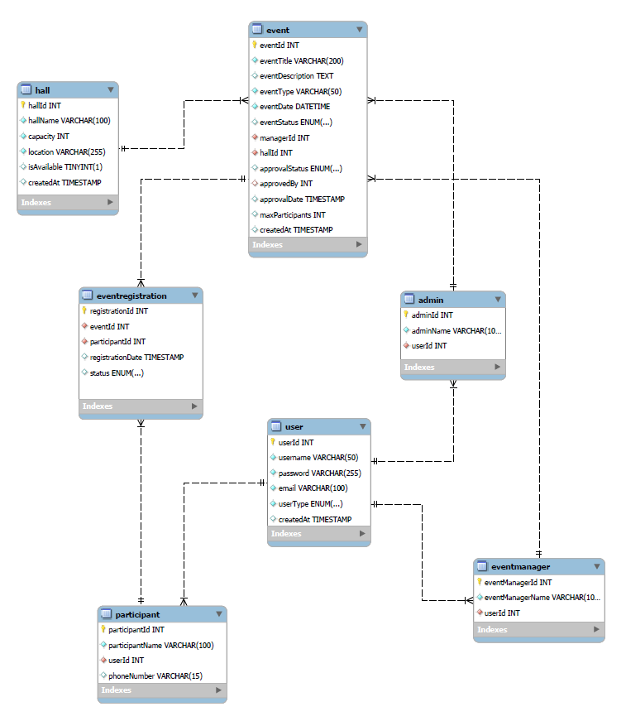

Welcome Page:
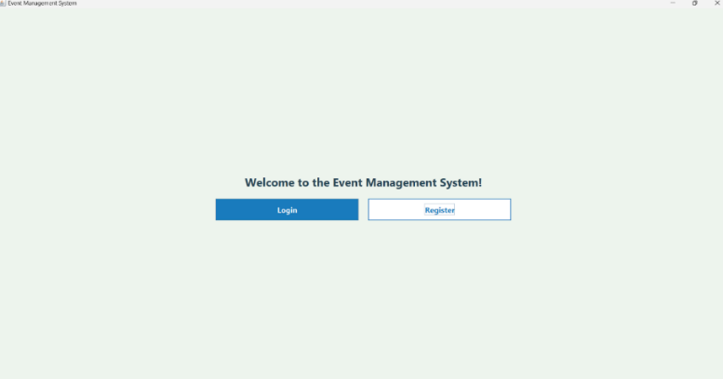
Figure 1
Creating an account:
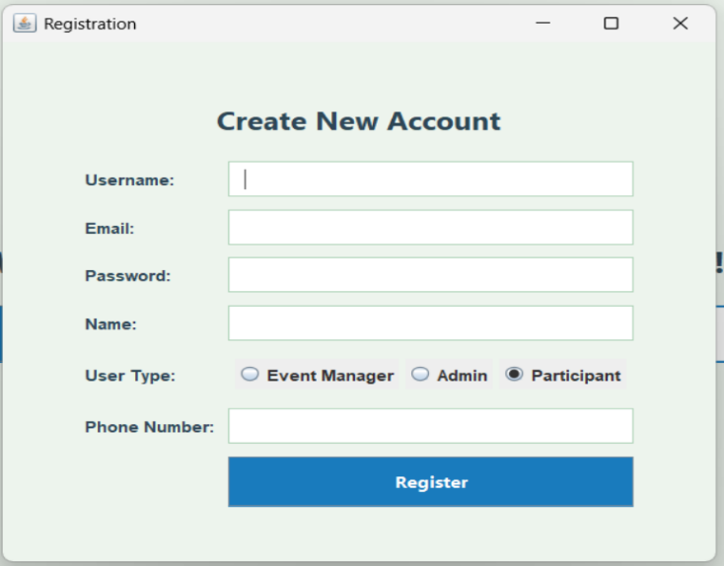
Figure 2
Logging in to an existing account:
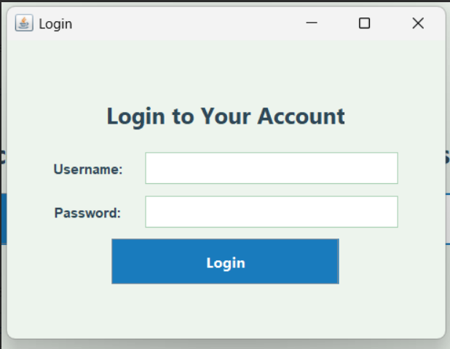
Figure 3

Event Manager Dashboard:
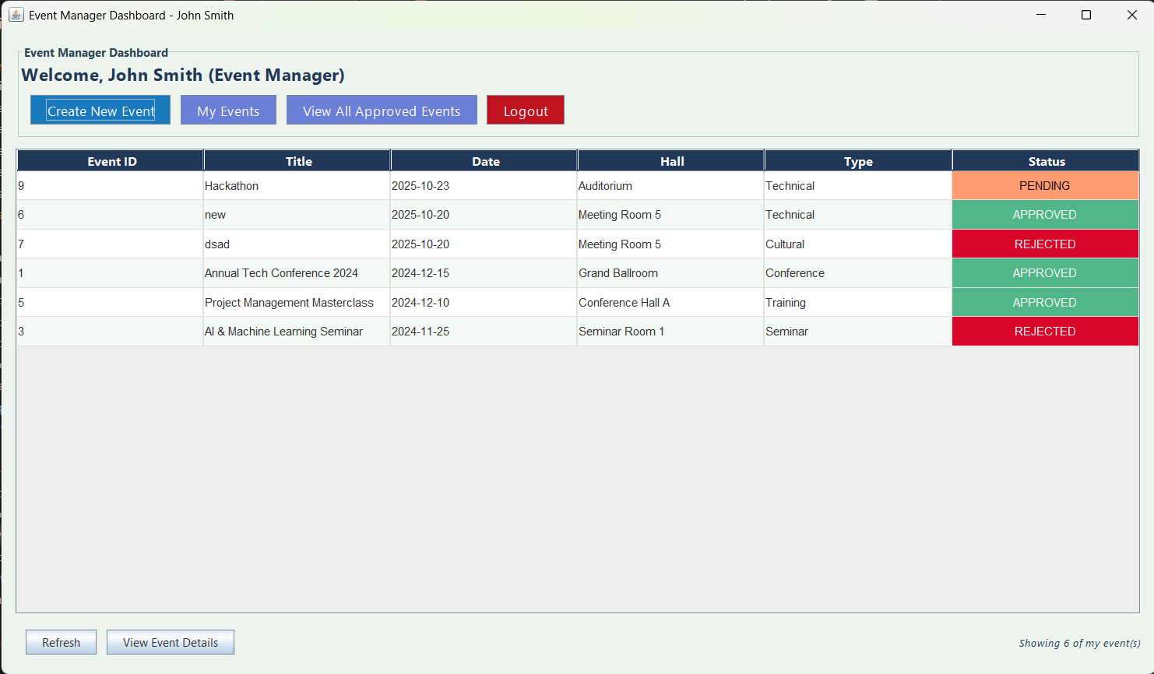
Figure 4
Creation of New Event:
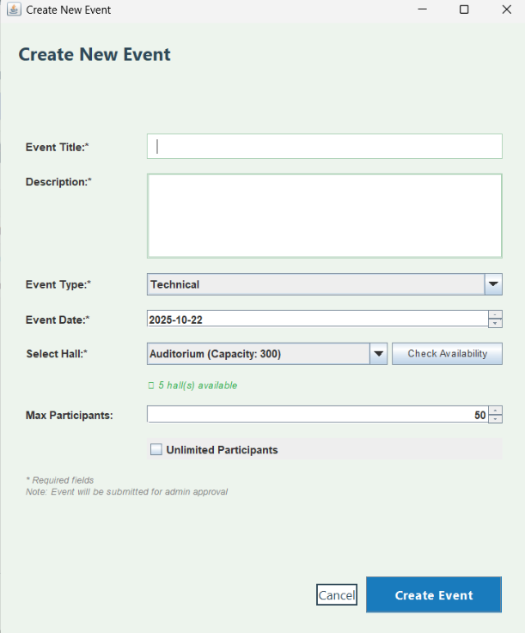
Figure 5

Admin Dashboard – View All Events:
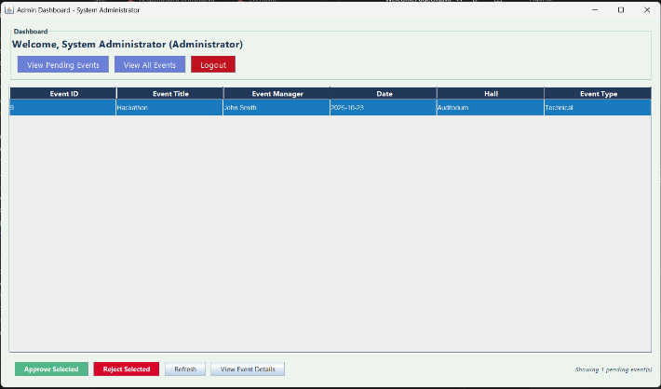
Figure 6
Admin Accept/ Reject Event Requests :
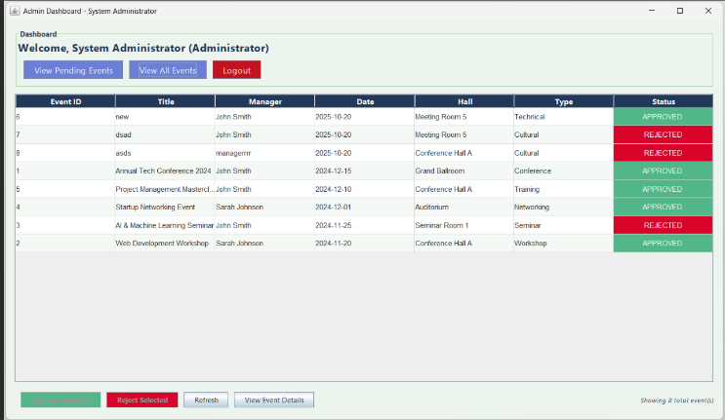
Figure 7
Participant Registration Dashboard:
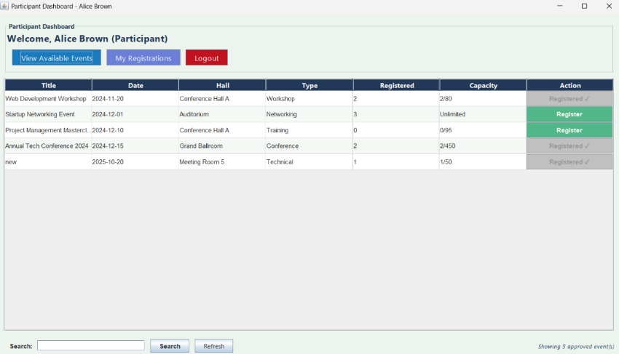
Figure 8

Cancel Registered Event :
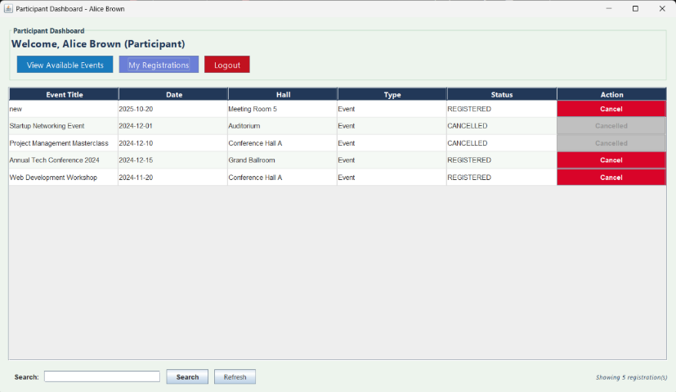
Figure 9

View event Details:
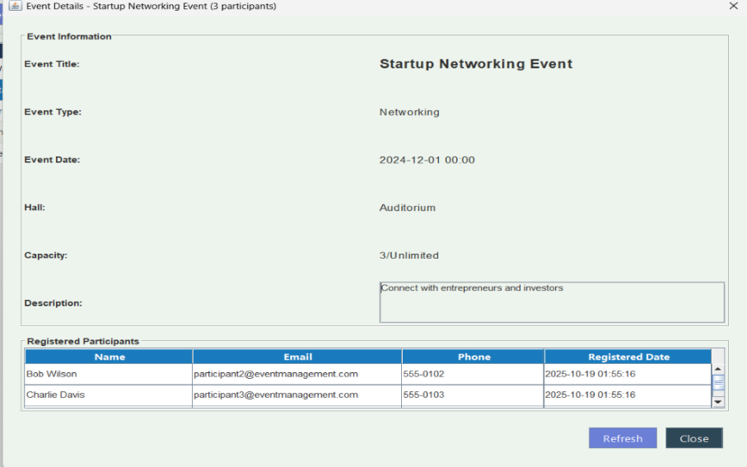
Figure 10

CHAPTER 5 SOFTWARE TESTING

5.1 Testing Strategy and Methodology

- Unit Testing: To test individual modules or functions in isolation. Each class & method in the application was tested independently to ensure correct logic& output.

2. Integration Testing: To ensure that different modules work correctly when combined.
After successful unit testing, modules like Login, Event Management, and Database Connectivity were integrated and tested together.

3. System Testing: To test the complete, integrated application as a whole.
The system was tested to ensure all functionalities (event creation, approval, registration, etc.) work as per the specifications.

4. Validation Testing: To ensure the system fulfills user needs and requirements.The application was validated against the Software Requirements Specification (SRS).Ensuring that only approved events are visible to participants, and hall conflicts are avoided.

5. User Acceptance Testing (UAT): To confirm that the system is ready for real-world use.Conducted by sample users (students, staff) to test the interface, flow, and overall user experience.
.
6. Performance Testing: To evaluate system response and stability under load.Tested by simulating multiple users creating and viewing events simultaneously.

5.2 Test Case:

Various test cases were designed and executed to verify the correct functioning of the Event Management System. Each test case focused on validating a specific module or feature to ensure that it performed as expected under different conditions.

Testing Analysis

The testing phase of the Event Management System was carried out systematically to ensure that the entire application functioned as intended and met all user and system requirements. Each module was tested independently and then integrated with others to verify seamless operation across the system. The results of the testing process confirmed that both functional and non-functional requirements were successfully implemented.During unit testing, each module such as login, event creation, hall booking, and participant registration was tested individually to verify its logic and behavior. The modules produced the expected outputs for both valid and invalid inputs, confirming their correctness. Integration testing ensured that communication between the modules — such as data transfer between the user interface and the MySQL database — occurred accurately and without data loss or inconsistency.

In the system testing phase, the entire application was executed to verify that it operated correctly as a whole. All user roles (administrator, event manager, and participant) were tested under real-world scenarios. The application successfully handled all major operations like event creation, approval, rejection, and registration. The system displayed appropriate error messages for invalid inputs and prevented operations like duplicate registrations or hall conflicts, ensuring data integrity and consistency.The system’s interface, validation messages, and data flow met user expectations and provided a smooth experience.

Overall, the testing results revealed that the Event Management System is stable, efficient, and reliable. No major defects were found after final integration, and all minor issues identified during early testing were successfully resolved. The application met its objectives by providing a functional, secure, and error-free platform for event coordination and management.

5.3 Overall Findings and Quality Assessment
The overall findings from the testing and evaluation of the Event Management System indicate that the application performs efficiently, meets the intended objectives, and provides a smooth user experience. All core functionalities — including event creation, approval, hall booking, and participant registration — were tested thoroughly and found to operate correctly under normal as well as exceptional conditions. The system successfully validated user inputs, prevented duplicate records, and handled error conditions gracefully, which demonstrates its robustness and reliability.The database connectivity using JDBC proved stable, and data transactions were executed securely without loss or

corruption..Furthermore, code readability and modular design principles were maintained, making future updates or feature enhancements manageable. The system passed all critical test cases, and minor issues identified during the development phase were resolved effectively. The end users expressed satisfaction with the system’s speed, clarity, and reliability.
In conclusion, the Event Management System achieves a high level of software quality and fulfills all the intended requirements. It provides an organized, secure, and efficient platform for managing events, reducing manual effort, and improving coordination among administrators, event managers, and participants.

CHAPTER 6

CONCLUSION AND FUTURE ENHANCEMENT

6.1 Conclusion:

The Event Management System is a successful implementation of a desktop-based solution for organizing and managing events efficiently. Leveraging Java Swing for an interactive GUI and MySQL for robust data management, the system effectively handles event creation, approval, hall booking, and participant registration. The use of modern technologies and design patterns ensures data integrity, security, and smooth operation, while providing a scalable foundation for future enhancements. This project demonstrates how technology can streamline complex workflows, improve user experience, and support effective decision-making in event management.

6.2 Future Enhancements:

The Event Management System is a desktop-based application developed in Java with a Swing GUI and MySQL backend, designed to streamline the organization, approval, and participation process for events within an institution or organization. It provides a complete workflow where Event Managers can create events with detailed information including type, date, and hall selection, while the system ensures real-time hall availability and prevents double bookings. Administrators oversee the approval process, allowing events to move from pending to approved or rejected, with full tracking of decisions. Participants can browse approved events, register or cancel attendance, and view registration counts, with the system preventing duplicate registrations. The project implements a three-tier architecture separating the presentation, business logic, and data layers, uses DAO and singleton patterns for data access and session management, and maintains an intuitive, color-coded interface for easy tracking of event statuses. While the system successfully handles core event management operations, current limitations include plain-text password storage, lack of email notifications, limited search capabilities, and no transaction management, all of which are areas for potential enhancement in future versions.

6.3 Source Code

EventDAO.java
package com.eventmanagement;
import java.sql.*;
import java.util.ArrayList;
import java.util.List;

/**
* EventDAO - Data Access Object for managing Event table operations.
* Handles CRUD operations and event retrieval logic.
*/
public class EventDAO {
private Connection connection;
// Constructor
public EventDAO(Connection connection) {
this.connection = connection;
}

// ===============================
// 1️⃣ CREATE EVENT
// ===============================
public boolean addEvent(Event event) {
String query = "INSERT INTO Event (eventTitle, eventDescription, eventType, eventDate, eventStatus, " +
"managerId, hallId, approvalStatus, approvedBy, approvalDate, maxParticipants) " +
"VALUES (?, ?, ?, ?, ?, ?, ?, ?, ?, ?, ?)";
try (PreparedStatement stmt = connection.prepareStatement(query)) {
stmt.setString(1, event.getEventTitle());
stmt.setString(2, event.getEventDescription());
stmt.setString(3, event.getEventType());
stmt.setTimestamp(4, new Timestamp(event.getEventDate().getTime()));
stmt.setString(5, event.getEventStatus());

stmt.setInt(6, event.getManagerId());
stmt.setInt(7, event.getHallId());
stmt.setString(8, event.getApprovalStatus());
if (event.getApprovedBy() != null)
stmt.setInt(9, event.getApprovedBy());
else
stmt.setNull(9, Types.INTEGER);
if (event.getApprovalDate() != null)
stmt.setTimestamp(10, new Timestamp(event.getApprovalDate().getTime()));
else
stmt.setNull(10, Types.TIMESTAMP);
if (event.getMaxParticipants() != null)
stmt.setInt(11, event.getMaxParticipants());
else
stmt.setNull(11, Types.INTEGER);

return stmt.executeUpdate() > 0;
} catch (SQLException e) {
System.err.println("Error adding event: " + e.getMessage());
return false;
}
}

// ===============================
// 2️⃣ READ - GET ALL EVENTS
// ===============================
public List<Event> getAllEvents() {
List<Event> events = new ArrayList<>();
String query = "SELECT * FROM Event ORDER BY eventDate DESC";
try (Statement stmt = connection.createStatement();
ResultSet rs = stmt.executeQuery(query)) {
while (rs.next()) {

events.add(extractEventFromResultSet(rs)); }

} catch (SQLException e) {
System.err.println("Error fetching events: " + e.getMessage());
}
return events;
}

// ===============================
// 3️⃣ READ - GET EVENT BY ID
// ===============================
public Event getEventById(int eventId) {
String query = "SELECT * FROM Event WHERE eventId = ?";
try (PreparedStatement stmt = connection.prepareStatement(query)) {
stmt.setInt(1, eventId);
ResultSet rs = stmt.executeQuery();
if (rs.next()) {
return extractEventFromResultSet(rs);
}
} catch (SQLException e) {
System.err.println("Error fetching event by ID: " + e.getMessage());
}
return null;
}

// ===============================
// 4️⃣ UPDATE EVENT DETAILS
// ===============================
public boolean updateEvent(Event event) {
String query = "UPDATE Event SET eventTitle=?, eventDescription=?, eventType=?, eventDate=?, eventStatus=?, " +
"hallId=?, approvalStatus=?, approvedBy=?, approvalDate=?, maxParticipants=? WHERE eventId=?";

try (PreparedStatement stmt = connection.prepareStatement(query)) {

stmt.setString(1, event.getEventTitle());

stmt.setString(2, event.getEventDescription());
stmt.setString(3, event.getEventType());
stmt.setTimestamp(4, new Timestamp(event.getEventDate().getTime()));
stmt.setString(5, event.getEventStatus());
stmt.setInt(6, event.getHallId());
stmt.setString(7, event.getApprovalStatus());
if (event.getApprovedBy() != null)
stmt.setInt(8, event.getApprovedBy());
else
stmt.setNull(8, Types.INTEGER);
if (event.getApprovalDate() != null)
stmt.setTimestamp(9, new Timestamp(event.getApprovalDate().getTime()));
else
stmt.setNull(9, Types.TIMESTAMP);
if (event.getMaxParticipants() != null)
stmt.setInt(10, event.getMaxParticipants());
else
stmt.setNull(10, Types.INTEGER);

stmt.setInt(11, event.getEventId());

return stmt.executeUpdate() > 0;
} catch (SQLException e) {
System.err.println("Error updating event: " + e.getMessage());
return false;
}
}

// ===============================

// 5️⃣ DELETE EVENT

// ===============================
public boolean deleteEvent(int eventId) {
String query = "DELETE FROM Event WHERE eventId = ?";

try (PreparedStatement stmt = connection.prepareStatement(query)) {
stmt.setInt(1, eventId);
return stmt.executeUpdate() > 0;
} catch (SQLException e) {
System.err.println("Error deleting event: " + e.getMessage());
return false;
}
}

// ===============================
// 6️⃣ FILTER EVENTS BY MANAGER
// ===============================
public List<Event> getEventsByManager(int managerId) {
List<Event> events = new ArrayList<>();
String query = "SELECT * FROM Event WHERE managerId = ? ORDER BY eventDate DESC";
try (PreparedStatement stmt = connection.prepareStatement(query)) {
stmt.setInt(1, managerId);
ResultSet rs = stmt.executeQuery();
while (rs.next()) {
events.add(extractEventFromResultSet(rs));
}
} catch (SQLException e) {
System.err.println("Error fetching manager events: " + e.getMessage());
}
return events;
}

// ===============================

// Helper Method - Extract Event
// ===============================

private Event extractEventFromResultSet(ResultSet rs) throws SQLException {
Event event = new Event();

event.setEventId(rs.getInt("eventId"));
event.setEventTitle(rs.getString("eventTitle"));
event.setEventDescription(rs.getString("eventDescription"));
event.setEventType(rs.getString("eventType"));
event.setEventDate(rs.getTimestamp("eventDate"));
event.setEventStatus(rs.getString("eventStatus"));
event.setManagerId(rs.getInt("managerId"));
event.setHallId(rs.getInt("hallId"));
event.setApprovalStatus(rs.getString("approvalStatus"));
event.setApprovedBy((Integer) rs.getObject("approvedBy"));
event.setApprovalDate(rs.getTimestamp("approvalDate"));
event.setMaxParticipants((Integer) rs.getObject("maxParticipants"));
return event;
}
}

REFERENCES

- Oracle: MySQL Concepts & Benefits – https://www.oracle.com/mysql
- Prepbytes Blog: Java Swing Introduction – https://prepbytes.com/blog/introduction-to-java-swing/
- GeeksforGeeks: MVC in Java – https://www.geeksforgeeks.org/system-design/mvc-design-pattern
- OWASP: SQL Injection Prevention – https://cheatsheetseries.owasp.org
- GeeksforGeeks: Singleton Pattern in Java – https://www.geeksforgeeks.org/system-design/singleton-design-pattern
- HappyFox Blog: Approval Workflow Automation – https://blog.happyfox.com
- Authgear: RBAC Benefits – https://www.authgear.com
- . Oracle. (n.d.). JDBC API Documentation. Retrieved from https://docs.oracle.com/javase/
- www.tutorialspoint.com
- www.w3schoo1s.com
- W3Schools. [Online]. Available at: https://www.w3schools.com
- Oracle Corporation. (2023). Java Swing Documentation. [Online]. Available at: https://docs.oracle.com/javase/8/docs/api/javax/swing/
- JUnit Organization. (2023). JUnit 5 Framework Documentation. [Online]. Available at: https://junit.org/junit5/
- Apache Software Foundation. (2023). Log4j 2 Logging Framework. [Online]. Available at: https://logging.apache.org/log4j/2.x/
- PostgreSQL Global Development Group. (2023). JDBC Driver Documentation. [Online]. Available at: https://jdbc.postgresql.org/documentation/
- TutorialsPoint. (2023). Java Database Connectivity (JDBC) Tutorial. [Online]. Available at: https://www.tutorialspoint.com/jdbc/index.htm
- Baeldung. (2023). Spring and Java Tutorials. [Online]. Available at: https://www.baeldung.com
- DigitalOcean Tutorials. (2023). Java and Database Development Guides. [Online]. Available at: https://www.digitalocean.com/community/tutorials
GitHub Docs. (2023). Using Git and Version Control. [Online]. Available at: https://docs.github.com/
- JetBrains. (2023). IntelliJ IDEA and Java Development Documentation. [Online]. Available at: https://www.jetbrains.com/idea/documentation/
- JavaTpoint. (2023). Java Swing Tutorial. [Online]. Available at: https://www.javatpoint.com/java-swing
- MDN Web Docs. (2023). HTML, CSS, and JavaScript Reference. Mozilla Foundation. [Online]. Available at: https://developer.mozilla.org/
- /

